Australian TV So White – It’s Time For Some Radical Solutions


Osman Faruqi
Osman Faruqi is a Sydney-based writer, political campaigner and hip-hop nerd.

One of the most disconcerting things about flicking on the TV to watch a contemporary Australian drama or comedy program set in Melbourne or Sydney (and most of them are) is how unreal most scenes look. The buildings and landmarks are there to help identify the setting, but the frequent lack of racial diversity confuses you into thinking you’re watching a show set in an alternative universe where the numerous waves of mass migration to Australia’s biggest cities simply never occurred. Even more confusingly, delicious ethnic food like kebabs, Pad Thai and dumplings regularly feature in the diets of our happy white characters, but somehow the people that brought these things to Australia just don’t exist.
While Neighbours and Home and Away are regularly shamed for their shallow attempts to reflect “mainstream Australia” (and they deserve it – Home and Away, for example, has literally zero non-white characters in its current main cast list) the issue of diversity isn’t limited to soap operas or even commercial television. Last year’s popular ABC mini-series The Beautiful Lie was set in inner-city Melbourne, one of the most culturally diverse locations in the world, yet all ten of the main characters were white.
Wherever you look – drama, comedy, news, breakfast television, it’s frustratingly obvious that media representations of what “ordinary Australia” looks like are out of step with the fact that 30 per cent of us are born overseas.
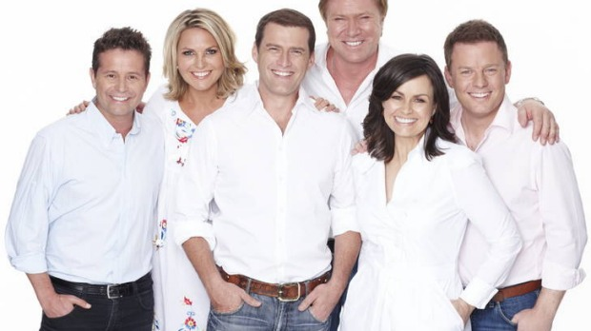
Blinded by the white

While countries like the United States have their own problems with representations of diversity (see the #OscarsSoWhite campaign) there is a much stronger culture of critiquing and calling out poor representation compared to Australia, and even racial diversity on the production side of shows and in writing rooms is regularly interrogated.
The reception to two new home-grown TV shows being released this year, The Family Law and Here Come the Habibs, is a great example of the awkward way that media portrayals of race and diversity are still received by local critics, audiences and networks.
Despite featuring a cast made up overwhelmingly of Asian-Australians, The Family Law, based on Benjamin Law’s best-selling memoir, is quite clearly not a show about race. One of the first lines in the show’s first episode, when Law explains to us that his mum isn’t weird because she’s Chinese, she’s just… weird, seems specifically constructed as a heads up to the audience that if you’re expecting slapstick humour based on racial stereotypes, this isn’t the program for you. The tension and the humour in the show doesn’t come purely from the character’s ethnicity, but from the hilarious yet highly relatable situations they find themselves in. However this hasn’t stopped The Family Law from being categorised alongside shows like Acropolis Now and The Kumars at No 42.
What these shows have in common is the main cast consisting of non-Anglo actors. But it’s absurd to pretend that The Family Law is in the same category as a Nick Giannopoulos skit, which almost exclusively derives its humour from racial stereotypes. In this way The Family Law is similar to Master of None, Aziz Ansari’s critically acclaimed Netflix series. Neither of them are explicitly about race, yet both have been labelled “comedies about race and diversity”.
This is unlikely to change as long as shows that feature diverse casts and are written by diverse teams remain rare exceptions, rather than regular features of our cultural fabric. It’s precisely because these types of shows are so uncommon, that they are lumped together despite a distinct lack of similarity.
Unlike The Family Law, Here Come the Habibs is premised around finding humour specifically in the clash of cultures. In this instance, an Australian-Lebanese family are up against the landed gentry of Sydney’s Eastern Suburbs. The program has attracted significant controversy before it has aired, for what appears to be crude stereotyping.
On a recent Guardian Australia podcast, one of the show’s creators, Tahir Bilgiç, stated that none of the writers were actually of a Lebanese background, something he and his co-creator were concerned about. I think it’s fair enough to reserve judgement about Here Come the Habibs until it actually airs, but the fact that a show that revolves entirely around racial tension didn’t feature any non-white writers is actually extraordinary, and a good example of the issues we face here.

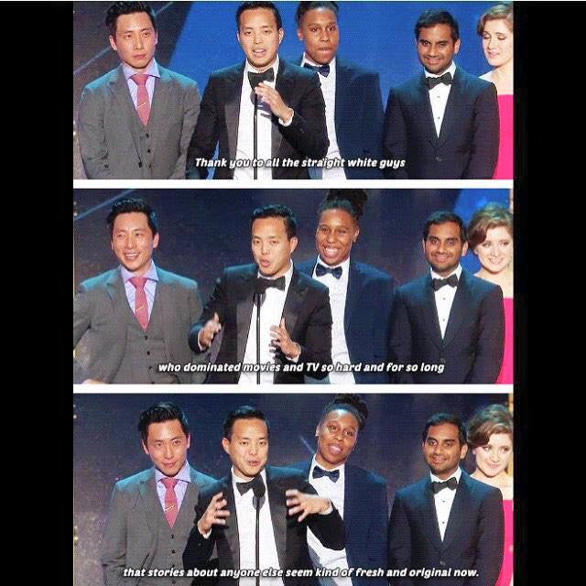

Alan Yang landed this smackdown when ‘Master of None’ named best comedy at Critics’ Choice Awards
More often than not when Australian television does feature more diverse casts, it’s in an explicit rather than subtle way. For example, we’re more likely to see Indigenous Australians on a show like Black Comedy and on NITV then we are on Sunrise or on one of the 700 shows featuring Asher Keddie as a bewildered single woman searching for love and professional success. Similarly, we only seem to get Lebanese Australians on television when they’re being chased by the cops (Pizza), making kebabs (Kebab Kings), fighting with rich white people (Here Come The Habibs), or featuring in gritty crime dramas on SBS.
There seems to also be a reluctance to seriously and regularly engage with the issue. While comedy shows in the US are regularly critiqued for failing to represent diversity on screen and off screen, there doesn’t appear to be any analysis of the fact that shows like Charlie Pickering’s The Weekly features an all white cast and writing team.
There are lots of reasons why the Australia we see on television doesn’t look like the Australia we see when we walk down the street. Some of it has to do with the fact that many minority groups experience significant disadvantage, and have substantial hurdles to overcome before they can even think about making it to the upper echelons of Australian media. Some of it has to do with outright racism amongst producers, television executives, and sadly, probably audiences too. But I think we can do better.
The good news is there are a bunch of things we can do to improve the situation – and they work. Many networks in the United States have quotas for racial diversity. And while they are far from perfect, they have also been credited for resulting in a record number of shows featuring actors from diverse backgrounds. Networks in the United Kingdom are considering introducing them as a response to the all-white casts of many popular shows.
Here in Australia, even at the ABC which is considered far more progressive than the commercial networks, only 8 per cent of content makers come from a non-English speaking background, compared to a figure of 15 per cent for the whole country. And that 8 per cent includes ABC staff who speak Italian, German and other European languages. If women were underrepresented at our networks by a factor of 50 per cent we wouldn’t (and shouldn’t) hesitate in introducing affirmative action to address the issue. And if you think it’s about “merit” all you’re saying is that non-white actors and broadcasters are just worse than white ones.
Last year Screen Australia announced a $5 million plan to fund a program designed to address the gender imbalance within Australian film and television. It’s a great initiative, but should we stop there? A similar program to encourage more diversity across our media landscape could help actors, writers and producers from multicultural backgrounds breakthrough in the industry.
Talented writers and actors from diverse backgrounds that have managed to smash through Australia’s ‘white ceiling’ have worked hard and should be applauded. But we shouldn’t stop there. We need to ensure that shows that feature real diversity on screen like The Family Law become common enough that we don’t have to write articles about how unique they are anymore.

